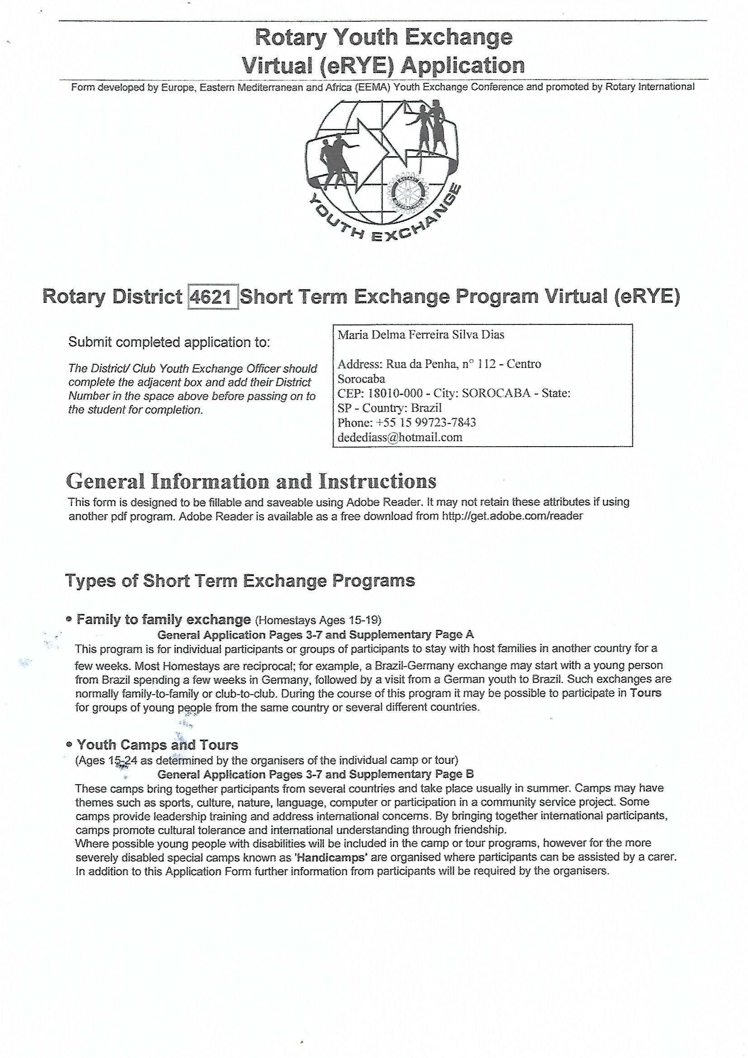

Read all directions on each page carefully before completing the application.
If you are accepted into the short term program this application will be sent to the hosting country and will serve as your introduction to the people who will organize your stay or host you.

Components of Your Application
- General Information: Pages 3 - 7 containing your Personal Information, Acceptance of the Rules and Conditions and the Guarantee Form;
- Supplementary Information: Pages A or B dependent upon the program in which you wish to participate; • Copy of your passport or birth certificate.

Completing your Application
The form is designed to be completed on a computer and unless there are special circumstances which prevent computer generated applications then this is the preferred method.
Answer all questions completely and as asked (do not write “same,” “see above,” or “see page ”). Enter the information into the space provided unless directed otherwise. To avoid any chance of misinterpretation take care with your grammar and spelling.
If completing by hand your application must be legible. Particular care should be taken with email addresses. Wherever the application asks for your full legal name, enter your name exactly as it appears on your passport or birth certificate. On pages that have a box in the upper right-hand corner marked “Applicant Name”, enter the preferred form of your name. For example, an applicant whose full legal name is Joseph David Smith might enter Joseph Smith or Joe Smith. Printing Your Application and Signing the Forms
You must submit four complete printed sets of this application. (You may also wish to make an additional set for your own records.) Sets 2-4 can be good quality photocopies. On all copies the signatures must be ORIGINAL. To achieve this:
- Complete the application form but do not sign it.
- Print four sets of the completed application (if completing by hand, make three good-quality photocopies of the original).
- Add your signature and those of your parents/legal guardians to all copies.
The photo of yourself on Page 3 may be digitally inserted or attached. If attached it must be an original photograph on all four sets, not a color photocopy, The photos submitted as part of Supplementary Page A may also be digitally inserted but, if attached, must include at least one set of originals. The other three sets may be good-quality color photocopies.

If you have been told that the form can be submitted electronically then the completed form should be saved as (yourname).pdf and submitted with a separate copy of Page 6 complete with all signatures.
To insert digital photographs using Adobe Reader
Open a new document in WORD. Select Insert > Picture then select the photo from file and click „Insert‟ button. Drag corner of photo to resize to approximately 5.5cm x 6 cm (2in. x 2.5in.) then position cursor over photo> right click> left click on „copy‟ from drop down menu.
Open the STEP Application Form in Adobe Reader and go to page 3.
If using Adobe Reader 9 select Tools > Comment & Mark Up > Stamps > „Paste Clipboard Image as Stamp Tool‟. If using Adobe Reader X select Comment> Annotations> left click on stamp icon> left click on „Paste Clipboard Image as Stamp Tool‟.
Position stamp shaped cursor over box headed ‘Smile!’> double left click> resize and position photo.
NOTE:- When printing the form the 'Documents and Stamps' setting must be selected in the „Comments and Forms‟ box of the Print Set Up otherwise the photo will not be printed.
Questions? If you have any questions about completing this application, check with your local Rotary Club‟s Youth Exchange officer. Once you‟ve completed your application, return it to your local Rotary Club/District as instructed.

Data Protection
Your information will be shared with Rotary International, the Sending and Hosting Rotary Districts Youth Exchange Organizations’ and Clubs, your appointed counselor and host families. It will only be used for official RI business and not sold to or shared with other third parties, unless required by law to be released.

Statement of Conduct for Working with Youth
Rotary International strives to create and maintain a safe environment for all youth who participate in Rotary activities. To the best of their ability Rotarians, Rotarians’ spouses, partners, and other volunteers must safeguard the children and young people they come in contact with and protect them from physical, sexual and emotional abuse.
Adopted by the Rotary International Board of Directors, November 2006

Page 2

1.

Program

Information

Rotary District
4621

Short
-
Term Exchange Program

Virtual

)
eRYE
(

Personal Information

Before you begin your
application, please
read all instructions on the prior pages.

This application refers to the following Short Term Exchange Program (please tick the appropriate box):
Family to Family Individual Exchange Group Exchange / Tours |  |  | Youth Camps  Other

2. Applicant Information
Full Legal Name as on passport or birth certificate (use capital letters for your FAMILY name; e.g., SMITH John David) |  |  |  |  |  | Name You Wish to be Called |  |  |  | Male Female
Date of Birth (e.g., 23/April/1999) | Citizen of (Country) |  |  | Place of Birth (City, State/Province, Country)
Home Address – Street |  | Town/City |  |  | State/Province |  |  | Postal Code | Country
Postal Address (if different) - Street |  | Town/City |  |  | State/Province |  |  | Postal Code | Country
E-mail Address |  |  | Home Phone Number  -------------------- |  |  |  | Mobile Phone Number

3. Parent/Legal Guardian Information (Preferred but not essential if applicant is over 18 years of age)
Full Name of Father/Legal Guardian |  | Rotarian?  Yes No | If yes, name of Rotary Club
Address – Street | Town/City |  | State/Province |  | Postal Code | Country
E-mail Address |  | Home Phone Number  --------------------------- |  | Mobile Phone Number
Occupation |  | Business Phone Number |  | Fax Phone Number
Full Name of Mother/Legal Guardian |  | Rotarian?  Yes No | If yes, name of Rotary Club
Address – Street | Town/City |  | State/Province |  | Postal Code | Country
E-mail Address |  | Home Phone Number  -------------------------------------- |  | Mobile Phone Number
Occupation |  | Business Phone Number |  | Fax Phone Number
Parent/legal guardian to contact first in the event of an emergency (specify “Father”, “Mother”, etc.):
Check here if your parents are divorced or separated. If applicant is under 18 authorizations must be obtained from all parents/legal guardians and
others who have legal rights to decisions affecting the student’s participation. Explanation is required if signatures of two parents or legal guardians are not provided.

Applicant’s Name

4. Personal Background
Religion | Do you have any special requirements regarding religious observance? Please detail:-
Dietary Restrictions | (Enter “None”, or explain with details – e.g., vegetarian, vegan, allergic to…)
Do you smoke or use tobacco products?  Yes No | If yes, please explain.
Do you drink alcohol?  Yes No | If yes, please explain.
Have you ever used illegal drugs?  Yes No | If yes, please explain.
Answering yes to any of these questions will not necessarily eliminate you as a candidate; however, special consideration may be required with regards to host family or host country.

5. Languages

Your Native Language |  |  | Proficiency in Non-Native Language(s) (indicate Poor, Fair, Good, or Fluent)
Non-Native Language(s) | Years Studied | Speaking |  | Reading | Writing

6. Health Information
Yes No
Yes No
Yes No
Yes No
Do you have any mental health/medical/dental conditions?
Have you been treated for mental health/medical conditions in the past two years?
Have you taken any prescribed medications in the past six months?
Do you have any special health requirements (disabilities, allergies etc.)?

If you have answered ‘YES’ to any of the above please explain fully in the space below providing as much information as possible, including the name of any medication and the reason prescribed and include a copy of the doctor’s prescription. Use additional sheets of paper if necessary.
For more personal and background information please use the appropriate Supplementary Page.

7. Sending District and Club Contacts (to be completed by Sending Rotary Club and District representatives)
Sending District Number | Name of Sending District Youth Exchange Chair |  |  | E-mail Address
Address – Street |  | Town/City  Sorocaba |  | State/Province |  | Postal Code | Country
Home Phone Number | Business Phone Number Mobile Phone Number Fax Number
Sending Rotary Club Rotary | Name of Sending Club Youth Exchange Officer |  |  | E-mail Address
Address – Street |  | Town/City |  | State/Province |  | Postal Code | Country
Home Phone Number | Business Phone Number |  | Mobile Phone Number |  | Fax Number
Page 4

Applicant’s
Name

Rotary District 4621 Short-Term Exchange Program Virtual (eRYE)
Rules and Conditions of Exchange,
Permissions and Declarations
As a Youth Exchange Program participant supported by a Rotary club or district, you must agree to the following rules and conditions of exchange. Violation of any of these rules may result in dismissal from the program and immediate return home, at your expense. Please note that districts may edit this document or insert additional rules if needed to account for local conditions.

Rules and Conditions of Exchange
- You must obey the laws of the host country. If found guilty of violating any law, you can expect no assistance from your sponsors or native country. You must return home at your own expense as soon as released by authorities.
- You will be under the host district‟s authority while you are an exchange program participant and must abide by the rules and conditions of exchange provided by the host district. Parents or legal guardians must not authorize any extra activities directly to you. Any relatives you may have in the host country will have no authority over you while you are in the program.
- You are not allowed to possess or use illegal drugs.
Medicine prescribed to you by a physician is allowed.
- The illegal drinking of alcoholic beverages is expressly forbidden. Students who are of legal age should refrain. If your host family offers you an alcoholic drink, it is permissible to accept it under their supervision in the home.
- You may not operate a motorized vehicle, including but not limited to cars, trucks, motorcycles, aircraft, all- terrain vehicles, snowmobiles, boats, and other watercraft, or participate in driver education programs.
- You must have travel insurance that provides coverage for accidental injury and illness, third party liability, death benefits (including repatriation of remains), disability/ dismemberment benefits, emergency medical evacuation, emergency visitation expenses, 24-hour emergency assistance services, and legal services, in amounts satisfactory to the host Rotary club or district, with coverage from the time of your departure from your home country until your return.

- You must purchase return travel ticket before departure from the home country.
- You must attend all orientations and trainings offered by the sending and host districts and clubs.
- You must have sufficient financial support to assure your well-being during your exchange. Your host district may require a contingency fund for emergency situations. Unused funds will be returned to you or to your parents or legal guardians at the end of your exchange.
- You must follow the travel rules of your host district. Travel is permitted with host parents or for Rotary club or district functions authorized by the host Rotary club or district with proper adult chaperones. The host district and club, host family and if you are under 18, your parents or legal guardians must approve any other travel in writing, thus exempting Rotary of responsibility and liability.
- You must return home directly by a route mutually agreeable to your host district and, if under 18, your parents or legal guardians.
- Any costs related to an early return home or any other unusual costs (language tutoring, tours, etc.) are the responsibility of you and your parents or legal guardians.
- You should communicate with your host family, if applicable, prior to leaving your home country. The family‟s information must be provided to you by your host club or district prior to your departure.
- Visits by your parents or legal guardians, siblings, or friends while you are on exchange are strongly discouraged. Such visits may only take place with the consent of the host club and district and within their guidelines.
- Talk with your host counselor or other trusted adult if you encounter any form of abuse or harassment.

Recommendations for a Successful Exchange
- Smoking is discouraged. If you state in your application 5) Avoid serious romantic activity. Abstain from sexual that you do not smoke, you will be held to that position activity.
throughout your exchange. 6) Do not borrow money. Pay any bills promptly. Ask
- If placed in a host family, respect your host‟s wishes. permission to use the phone or computer, keep track of Become an integral part of the family, assuming duties all calls and time on the Internet, and reimburse the costs and responsibilities normal for a person of your age or you incur.
for children in the family. 7) Limit your use of the Internet and mobile phones.
- Make an effort to learn the basics of the language of the Excessive or inappropriate use is not acceptable.
host country. 8) If you are offered an opportunity to go on a trip or attend 4) Attend Rotary-sponsored events and, if living with a an event, make sure you understand any costs you must family, host family events, and show an interest in these pay and your responsibilities before you go.
activities. Volunteer to be involved - do not wait to be asked.

Page 5

Applicant’s Name

Rotary District 4621 Short-Term Exchange Program Virtual (eRYE) Guarantee Form

Full Legal Name as on passport or birth certificate (use capital letters for your FAMILY name; e.g., SMITH John David) |  |  |  | Name You Wish to be Called |  |  |  | male female
Place of Birth (City, State/Province, Country |  | Citizen of (Country) |  |  | Date of Birth (e.g., 01/Jan/1999)
Home Address – Street | Town/City |  | State/Province |  |  | Postal Code | Country
E-mail Address |  | Home Phone Number |  |  | Mobile Phone Number
SENDING CLUB
Sending District No. | Sending Club Name |  | Sending Club ID No.
Name of District Youth Exchange Chair | Name of Club President | Name of Club Secretary / YEO
Alternative Emergency Contact for student in home country, OTHER THAN A PARENT/GUARDIAN
Name |  |  | Relationship
Home Address – Street Town/City |  |  | State/Province Postal Code Country
E-mail Address | Home Phone Number | Business Phone Number |  | Mobile Phone Number
HOST DISTRICT and CLUB GUARANTEE
The Rotary District, and Rotary Club where specified within this section, will provide room and board in approved homes, invite the applicant to participate in Rotary club and district events and activities typical of our country, and provide guidance and supervision to assure the applicant‟s welfare. The host Rotary District agrees to provide adequate training for host parents and Youth Exchange volunteers and orientation for the student upon his/her arrival.
Host Country | Host District No. | Host Club Name |  |  | Host Club ID No.
Name of District Youth Exchange Chair |  | Name of Host Club President |  | Name of Host Club Secretary /YEO
E-mail Address of District Youth Exchange Chair |  | E-mail Address of Host Club President |  | E-mail Address of Host Club Secretary/YEO
Signature of District Youth Exchange Chair |  | Signature of Host Club President |  | Signature of Host Club Secretary/YEO
Date | Home Phone Number | Date | Home Phone Number | Date | Home Phone Number
HOST DISTRICT or CLUB COUNSELOR (Individual Exchanges only)
Name |  |  | E-mail Address
Address – Street |  | Town/City |  | State/Province |  | Postal Code | Country
Home Phone Number | Business Phone Number |  | Mobile Phone Number |  | Fax Number
HOST FAMILY (if applicable?)
Name of Host Father |  | Host Father’s E-mail Address |  | Business Phone |  | Mobile Phone
Name of Host Mother |  | Host Mother’s E-mail Address |  | Business Phone |  | Mobile Phone
Host Family Home Address – Street |  |  | Town/City | State/Province | Postal Code |  | Country
Home Phone Number | Names and Ages of any Other Adults in the Home
Page 7

763 (En) STEP Issue 3.1 : May 2011
Applicant’s Name

Rotary District 4621
Short-Term Exchange Program Virtual (eRYE)
Supplemental information about applicants for
Family to Family Exchange - (Individual or Group.)

Letters and Photos
Applicant’s Letter
Write a letter introducing yourself to your future host club and host families. Keep in mind that this will be their first impression of you. Incorporate your answers to the following questions in your letter, providing as much detail as possible (if you need help generating details, also consider the italicized questions in brackets).
Specifications: Type your letter on a separate sheet (or sheets) of paper, and include your name on each. Attach your letter to this page. Maximum length: 3 pages.

- Do you have Siblings? (Describe gender, age, occupation etc.)
- What do you do in your free time?
- What you do at your school? (How many subjects do you take? What are they? How long are the classes? What is your daily schedule during the school year? Start with when you wake-up and discuss only one typical day’s schedule. Are you able to choose courses at your school? If so, which courses did you choose, and why?)
- What are your school interests and activities? What leadership positions have you held?
- How would you describe your home? (Do you have your own room, or do you share your room with others? Where in your house do you study? How far is your home from your school? Do you drive, ride a bus, or walk to school?)
- What are the occupations of your mother and father? (What product or service does each make or perform? What is her/his position or title?)
- How would you describe your community? (Is it in or near a major city? What is the population? industry? economy?)
- What are your interests and accomplishments? (Are you interested in art, literature, music, sports, other activities? How did you become interested in the activity? How long have you been interested? How much time do you devote to the activity?)
- What trips have you taken outside your country? Why did you take these trips, with whom, for how long? 10. What things do you dislike? (Do you dislike certain foods, animals, treatment by other people, etc.?)
- What do you feel are your strong, and weak, characteristics?
- What are your plans and ambitions for your further education and career? Why?
- What do you specifically hope to accomplish as an exchange student, both during your exchange and when you return?
Parent’s Letter (required if applicant under 18)
Write a letter to your son/daughter/ward’s host club and families, incorporating your answers to the following questions in your letter. Specifications: Type your letter on a separate sheet (or sheets) of paper, and include your son/daughter/ward’s name on each. Attach your letter to this page. Maximum length: 2 pages.

- How would you describe your son/daughter/ward’s relationship with you, your family and with their friends?
- How does he/she react to disagreement, discipline, and frustration?
- How does he/she handle challenging or difficult situations?
- What amount of independence do you give to him/her? What is his/her level of maturity?
- What makes you proud of him/her?
- Why do you want him/her to be an exchange student?
- Are there any other comments you would like to share with the host families?

Applicant’s Photos
Select a color photograph for each topic below, and insert in, or attach each photo to your letter with glue or double-sided tape (do not staple). Include brief captions, if necessary. At least one application set must have original photographs; color photocopies may be used on the other three sets. Digital photos may be used - see notes on Page 2

• MY FAMILY Photo that includes • MY HOME Photo of your house members of your immediate family or building where you live

Supplementary Page A

763 (En) STEP Issue 3.1 : May 2011

APPLICANT´S LETTER –

PARENT´S LETTER –

Applicant’s Name | MATHEUS HENRIQUE CARVALHO

Rotary District 4621
Short-Term Exchange Program Virtual (eRYE)
Supplemental information about applicants for

Youth Camps and Tours

Applicant’s Personal Background

Please answer the following questions:-

What are your free time activities?

What are your school, college or university education attainments and vocation?

What are your special interests and accomplishments?

Do you have special skills?

Could you contribute to entertainment (e.g. play musical instrument etc.)?

What is the reason for your programme participation (e.g. choice of specific youth camp)?

Other personal remarks.

Supplementary Page B
763 (En) STEP Issue 3.1 : May 2011

